**MINI PROJECT**

**“DATA MART”**

Buatlah sebuah data mart dari database DVD rental yang bisa memberikan informasi di bawah ini. Semua informasi bisa dilihat berdasarkan tahun, bulan, dan tanggal.

1. Melihat pendapatan sewa dari film berdasarkan:
2. Judul Film
3. Rating Film
4. Kategori Film

**Query :**

**SELECT**

**CONCAT_WS('_', *f*.film_id, DATE_TRUNC('month', *p*.payment_date)) AS *Identifier*,**

**DATE_TRUNC('month', *p*.payment_date) AS *bulan_payment*,**

***f*.film_id,**

***f*.title,**

***f*.rating,**

***fc*.category_id,**

**c.name,**

**SUM(*p*.amount) as *amount***

**FROM**

**film *f***

**JOIN**

**inventory *i* ON *f*.film_id = *i*.film_id**

**JOIN**

**rental *r* ON *i*.inventory_id = *r*.inventory_id**

**JOIN**

**film_category *fc* ON *fc*.film_id = *f*.film_id**

**JOIN**

**category *c* ON *c*.category_id = *fc*.category_id**

**RIGHT JOIN**

**payment *p* ON *r*.rental_id = *p*.rental_id**

**GROUP BY**

***f*.film_id,**

**DATE_TRUNC('month', *p*.payment_date),**

***f*.title,**

***f*.rating,**

***fc*.category_id,**

**c.name**

**ORDER BY film_id;**

**Hasil :**

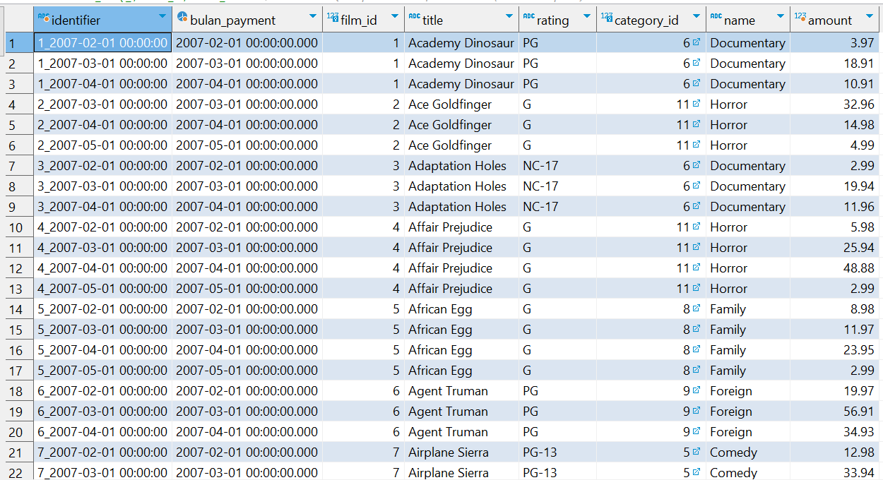

2. Melakukan segmentasi Customer:

1. Frekuensi Peminjaman
2. Total Biaya Sewa
3. Jenis film yang sering di sewa (kategori film dan rating film)

**Query :**

**WITH Sg_customer AS (**

**SELECT**

**r.customer_id,**

**DATE_TRUNC('month', r.rental_date) AS bulan,**

**COUNT(DISTINCT r.rental_id) AS frekuensi_peminjaman,**

**SUM(p.amount) AS total_biaya_sewa**

**FROM**

**payment p**

**LEFT JOIN**

**rental r ON r.rental_id = p.rental_id**

**JOIN**

**customer c ON r.customer_id = c.customer_id**

**GROUP BY**

**r.customer_id,**

**DATE_TRUNC('month', r.rental_date)**

**)**

**,**

**films AS (**

**SELECT**

**r.customer_id,**

**DATE_TRUNC('month', r.rental_date) AS bulan,**

**fc.category_id,**

**c.name AS category_name,**

**f.rating,**

**COUNT(*) AS jumlah_sewa,**

**ROW_NUMBER() OVER (PARTITION BY r.customer_id, DATE_TRUNC('month', r.rental_date) ORDER BY COUNT(*) DESC) AS rank**

**FROM**

**film f**

**JOIN**

**film_category fc ON f.film_id = fc.film_id**

**JOIN**

**category c ON fc.category_id = c.category_id**

**JOIN**

**inventory i ON i.film_id = f.film_id**

**JOIN**

**rental r ON i.inventory_id = r.inventory_id**

**GROUP BY**

**r.customer_id,**

**DATE_TRUNC('month', r.rental_date),**

**fc.category_id,**

**c.name,**

**f.rating**

**)**

**SELECT**

**CONCAT_WS('_', sg_customer.customer_id, EXTRACT(MONTH FROM sg_customer.bulan)) AS kunci,**

**sg_customer.customer_id,**

**sg_customer.bulan,**

**sg_customer.frekuensi_peminjaman,**

**sg_customer.total_biaya_sewa,**

**films.category_name AS jenis_film,**

**films.rating,**

**films.jumlah_sewa AS frekuensi_peminjaman_kategori_rating**

**FROM**

**Sg_customer**

**INNER JOIN**

**films ON sg_customer.customer_id = films.customer_id AND sg_customer.bulan = films.bulan AND films.rank = 1**

**ORDER BY**

**customer_id ASC;**

**Hasil :**

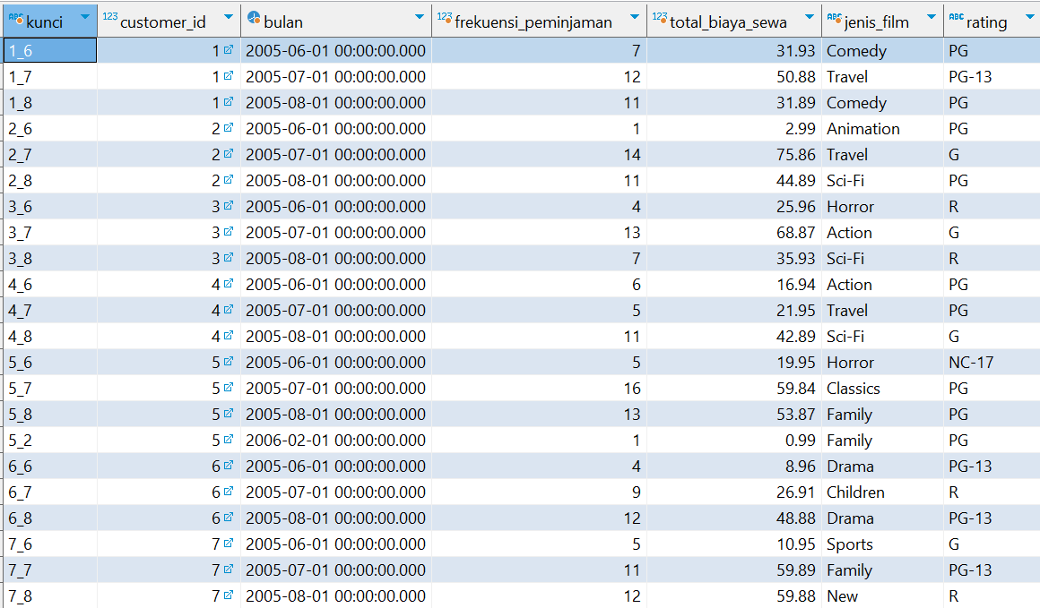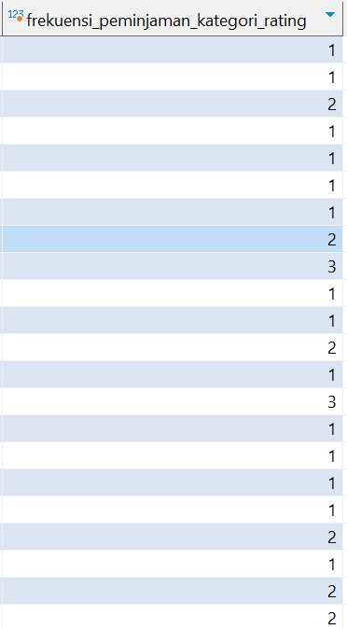

3. Melihat informasi keterlambatan sewa seperti :

1. Film yang paling sering terlambat dikembalikan
2. Berapa jumlah pembatalan dalam periode tertentu

Hint : Rumus untuk mengecek apakah penyewaan tersebut dinyatakan terlambat

Adalah, membandingkan rental duration film dan jarak antara tanggal peminjaman dan tanggal kembali.

**Query :**

**WITH Pinjam AS (**

**SELECT**

***f*.film_id,**

***i*.inventory_id,**

***r*.rental_id,**

***f*.title,**

***r*.customer_id,**

***f*.rental_duration,**

***r*.rental_date,**

***r*.return_date,**

**EXTRACT(day FROM *r*.return_date - *r*.rental_date) AS *Durasi_penggunaan_asli***

**FROM**

**film *f***

**JOIN**

**inventory *i* ON *f*.film_id = *i*.film_id**

**JOIN**

**rental *r* ON *i*.inventory_id = *r*.inventory_id**

**),**

**Keterlambatan AS (**

**SELECT**

**film_id,**

**COUNT(*) AS Jumlah_keterlambatan_pengembalian_tiap_film**

**FROM**

**Pinjam**

**WHERE**

**Durasi_penggunaan_asli > rental_duration**

**GROUP BY**

**film_id**

**),**

**Pembatalan as(**

**select**

**film_id,**

**count(*) as pembatalan**

**from pinjam**

**where return_date is null**

**group by film_id**

**)**

**SELECT**

**p.film_id,**

**p.rental_id,**

**p.customer_id,**

**p.rental_date,**

**p.return_date,**

**p.rental_duration,**

**p.durasi_penggunaan_asli,**

**case**

**when**

**p.durasi_penggunaan_asli > p.rental_duration then p.durasi_penggunaan_asli - p.rental_duration**

**else 0**

**end as durasi_terlambat_hari,**

**p.title,**

**k.Jumlah_keterlambatan_pengembalian_tiap_film,**

**pl.pembatalan**

**FROM**

**pinjam p**

**JOIN**

**Keterlambatan k ON p.film_id = k.film_id**

**join**

**pembatalan Pl on pl.film_id = p.film_id**

**ORDER BY**

**k.Jumlah_keterlambatan_pengembalian_tiap_film desc;**

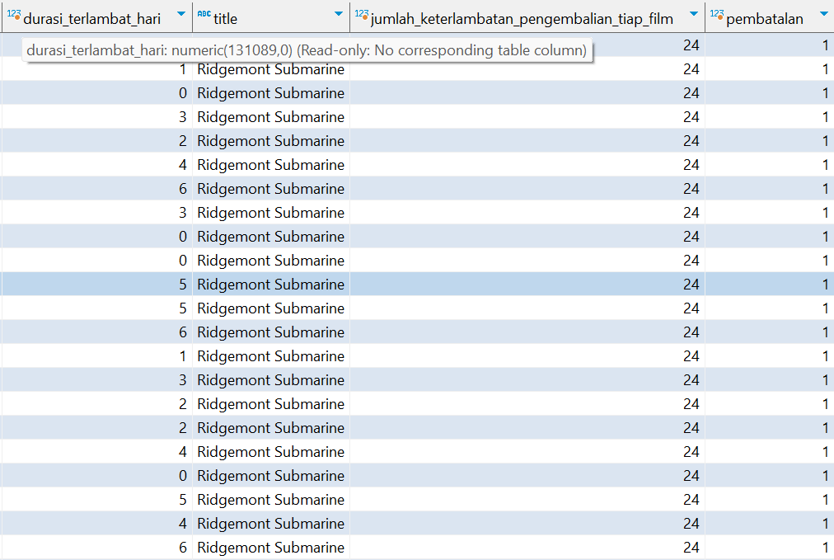

**Hasil :**

